Dual Axis Solar Tracking System with Weather Sensor
Solar power is the fastest growing means of renewable energy. The project is designed and implemented using simple dual axis solar tracker system. In order to maximize energy generation from sun, it is necessary to introduce solar tracking systems into solar power systems. A dual-axis tracker can increase energy by tracking sun rays from switching solar panel in various directions. This solar panel can rotate in all directions. This dual axis solar tracker project can also be used to sense weather, and it will be displayed on LCD. This system is powered by Arduino, consists of servo motor, stepper motor, rain drop sensor, temperature and humidity sensor and LCD.

Block Diagram:

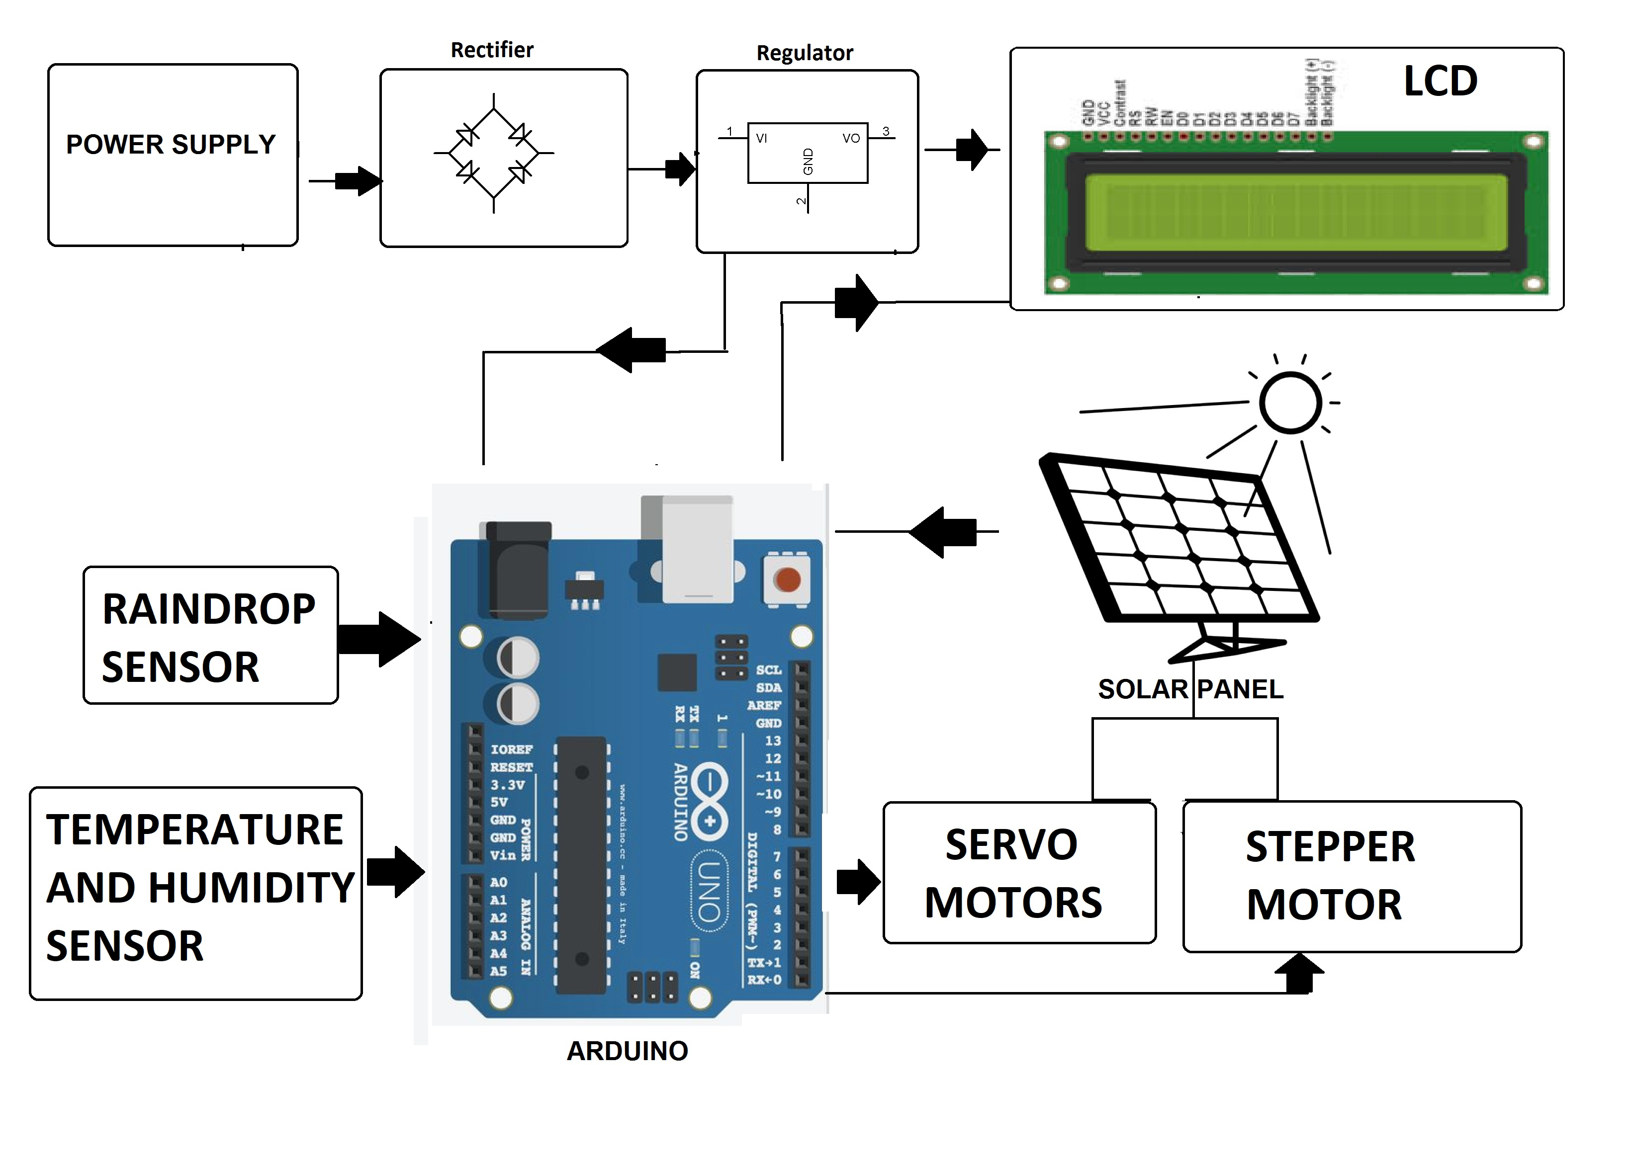

Hardware Specifications

- Atmega Microcontroller
- Solar Panel
- Servo Motor
- DC Motor
- Rain Sensor
- Humidity Sensor
- Temperature Sensor
- Resistor
- Capacitors
- Transistors
- Cables and Connectors
- Diodes
- PCB and Breadboards
- LED
- Transformer/Adapter
- Push Buttons
- Switch
- IC
- IC Sockets

Software Specifications

- Arduino Compiler
- Programming Language: C

